📝 Problem Statement
Agricultural crop diseases pose a significant threat to global food security and farm productivity, leading to substantial economic losses. Traditional methods of disease detection, which rely on manual visual inspection by experts, are often time-consuming, labor-intensive, and susceptible to human error, especially in large-scale farming operations. Delayed or inaccurate diagnosis can result in the inappropriate use of pesticides, increased costs, and widespread crop damage.

Goal
The goal is to develop an efficient, accurate, and automated disease detection system for five key crops—tomato, apple, cherry, radish, and walnut—to enable early and precise intervention.

Solution Approach
This project addresses this need by leveraging Deep Learning (VGG19) for automated feature extraction from crop images and a Support Vector Machine (SVM) classifier for robust and fast disease classification. This hybrid approach aims to surpass the limitations of manual inspection, providing farmers with a reliable tool for real-time crop health monitoring and management.

Formulae use for evaluation of each model :
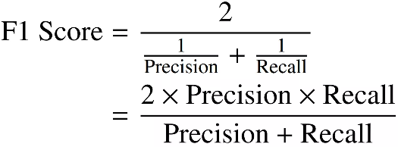
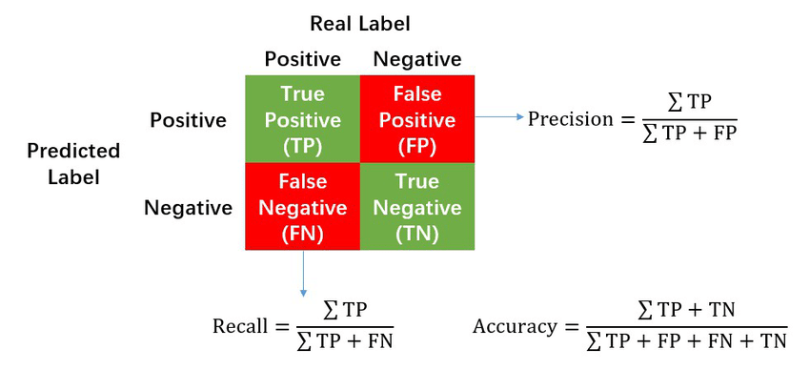

Tomato classes : ['late_blight', 'leaf_curl', 'spider mites', 'Fusarium Wilt', 'leaf_miner', 'bacterial_spot', 'leaf_mold', 'early_blight', 'septoria_leaf', 'healthy_leaf', 'verticillium wilt']
No of images in the dataset per class :
late_blight : 1112
leaf_curl : 1480
spider mites : 508
Fusarium Wilt : 318
leaf_miner : 1497
bacterial_spot : 1305
leaf_mold : 1510
early_blight : 1525
septoria_leaf : 1258
healthy_leaf 1478
verticillium wilt : 420
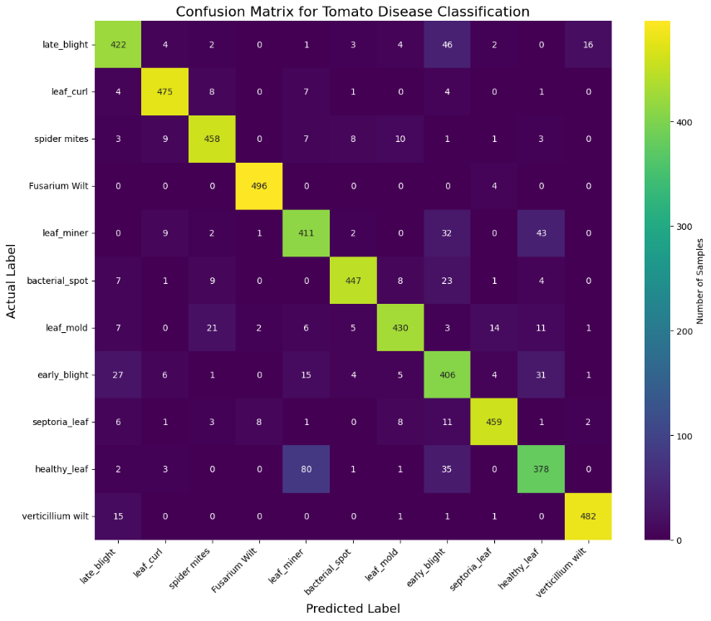

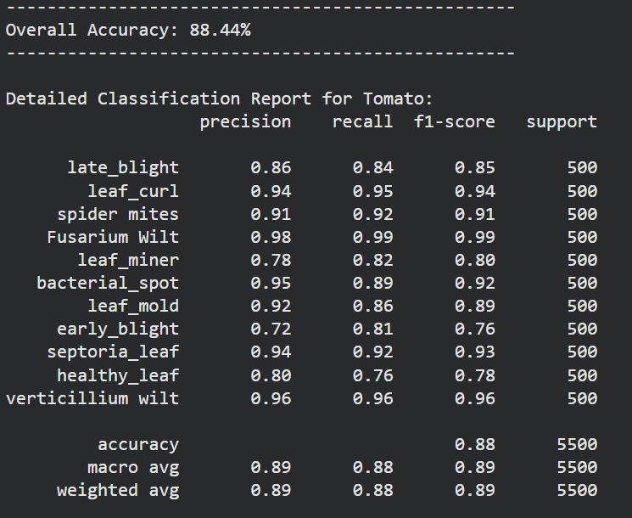

Apple :
Diseases : ['Apple Brown_spot', 'Apple black_spot', 'Apple Normal']
No of images in the dataset per class :
Apple Brown_spot :1060
Apple black_spot : 469
Apple Normal : 824

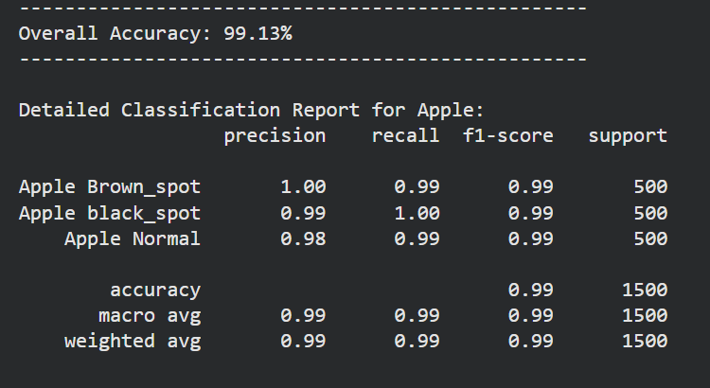

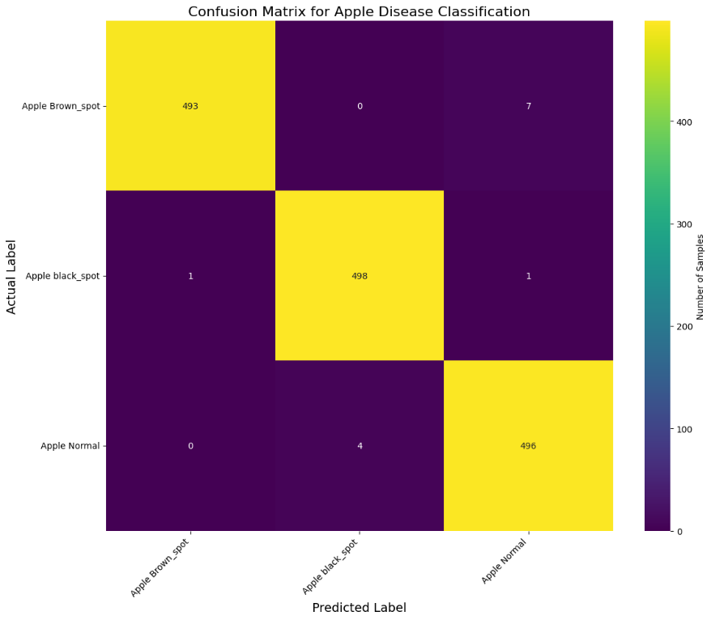

Cherry :
Diseases: ['Cherry purple leaf spot', 'Cherry Normal leaf', 'Cherry_shot hole disease', 'Cherry Leaf Scorch', 'Cherry brown_spot']
No of images in the dataset per class :
Cherry purple leaf spot : 987
Cherry Normal leaf : 500
Cherry_shot hole disease : 440
Cherry Leaf Scorch : 1101
Cherry brown_spot : 968
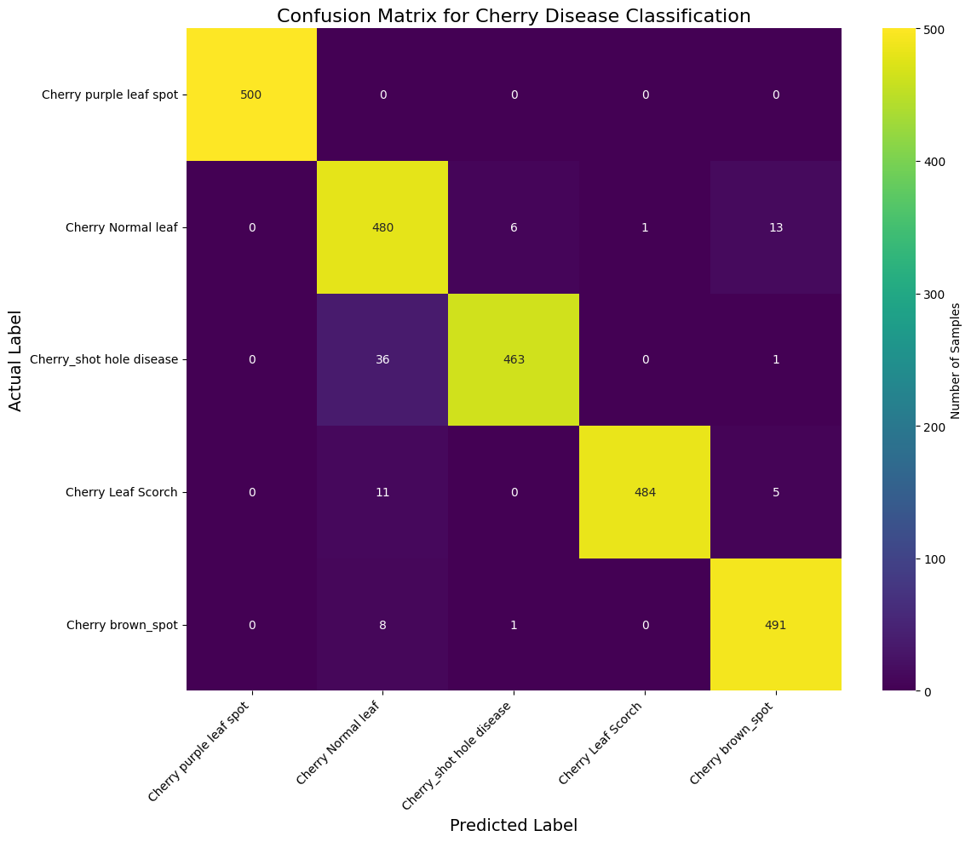

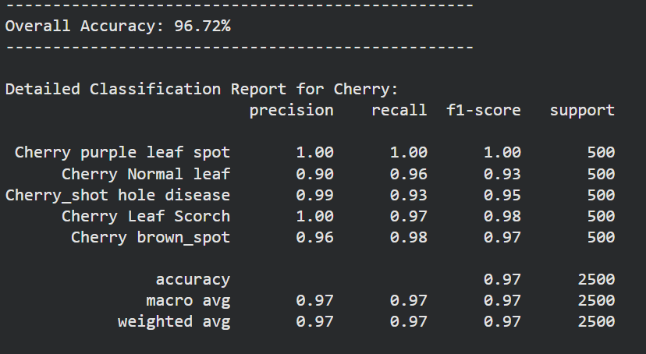

Radish :
Diseases : ['flea beetle', 'Black leaf spot', 'Downey mildew', 'Fresh leaf', 'Mosaic virus']
No of images in the dataset per class :
flea beetle : 513
Black leaf spot : 526
Downey mildew : 601
Fresh leaf : 613
Mosaic virus : 548
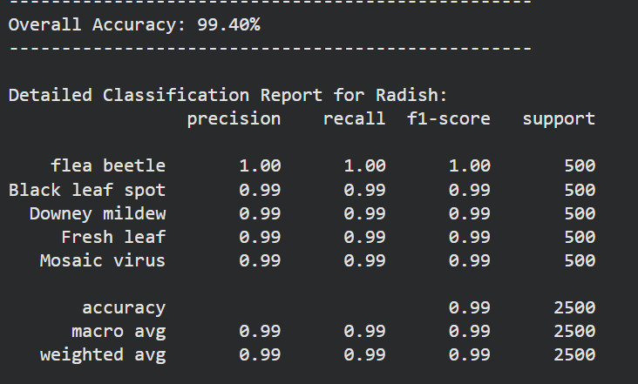
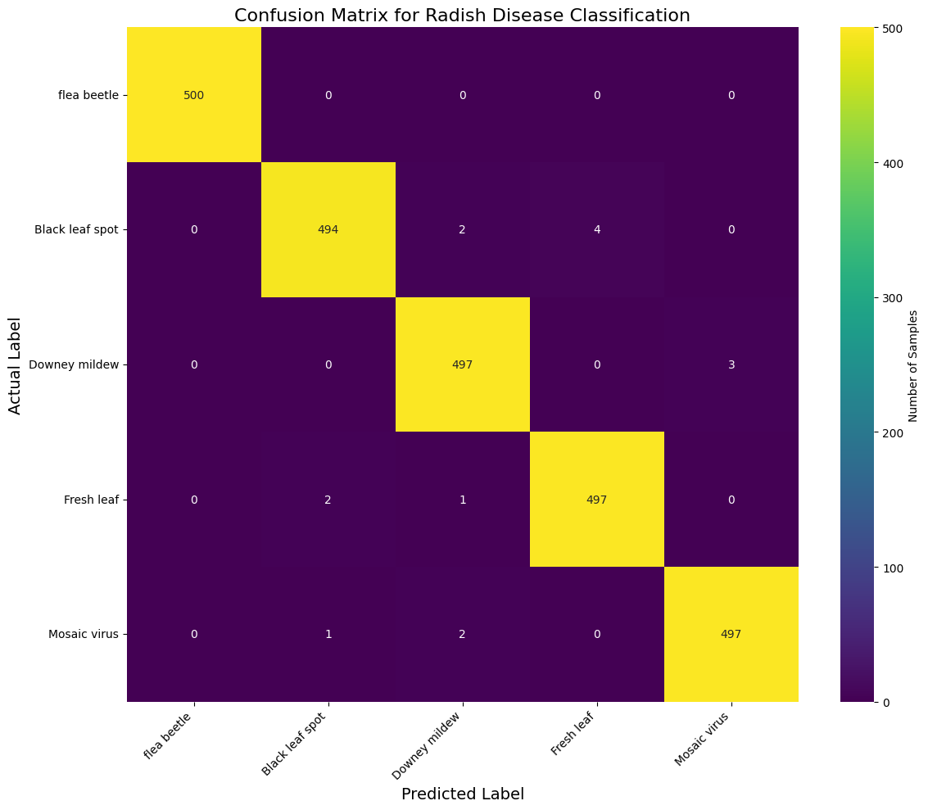

Walnut :
Diseases : ['Walnut Blotch_leaf disease', 'Walnut leaf gall mite', 'Walnut Normal_leaf', 'Walnut Anthracnose_leaf disease', 'Walnut Shot_hole']
No of images in the dataset per class :
Walnut Blotch_leaf disease : 1354
Walnut leaf gall mite : 392
Walnut Normal_leaf : 712
Walnut Anthracnose_leaf disease : 648
Walnut Shot_hole : 916
